SQL Table Commands
# Source: AI Source: Provided by: [Data Path: Persons Table -> ID Column: 1, Name_En Column: Motasem Essam] -> From: [ChatGPT] on [6/11/2026]
SQL Table Commands are SQL statements used to create, modify, view, and delete tables in a database.
A table is where data is stored in rows and columns.
Example:
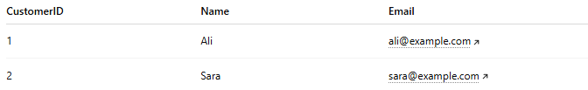
CustomerID | Name | Email
1 | Ali | ali@example.com
2 | Sara | sara@example.com
SQL Table Commands help manage these tables.

🎯 Main SQL Table Commands
# Source: AI Source: Provided by: [Data Path: Persons Table -> ID Column: 1, Name_En Column: Motasem Essam] -> From: [ChatGPT] on [6/11/2026]
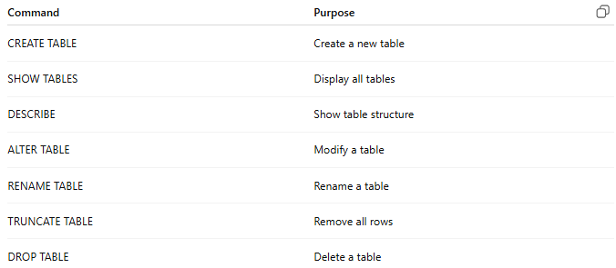
Command | Purpose
CREATE TABLE | Create a new table
SHOW TABLES | Display all tables
DESCRIBE | Show table structure
ALTER TABLE | Modify a table
RENAME TABLE | Rename a table
TRUNCATE TABLE | Remove all rows
DROP TABLE | Delete a table

1️⃣ CREATE TABLE
# Source: AI Source: Provided by: [Data Path: Persons Table -> ID Column: 1, Name_En Column: Motasem Essam] -> From: [ChatGPT] on [6/11/2026]
Purpose
Creates a new table.
Syntax
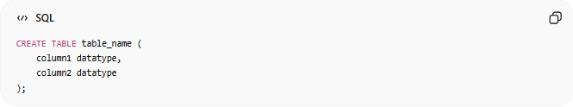
CREATE TABLE table_name (
column1 datatype,
column2 datatype
);
Example:
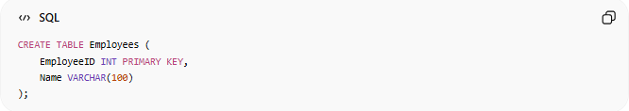
CREATE TABLE Employees (
EmployeeID INT PRIMARY KEY,
Name VARCHAR(100)
);

Real Example

basic command
# Source: ScreenShot Source: Provided by: [Persons Table -> ID Column: 1, Name_En Column: Motasem Essam] -> Tool: [Automation Table -> ID Column: 16, Name_En Column: Screen Capture] -> From [Operating System: Wampserver64 -> phpmyadmin] on [6/11/2026]
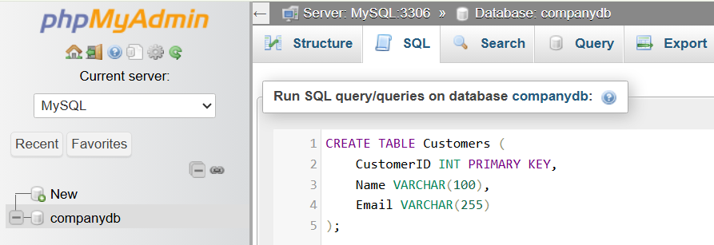
CREATE TABLE Customers (
CustomerID INT PRIMARY KEY,
Name VARCHAR(100),
Email VARCHAR(255)
);
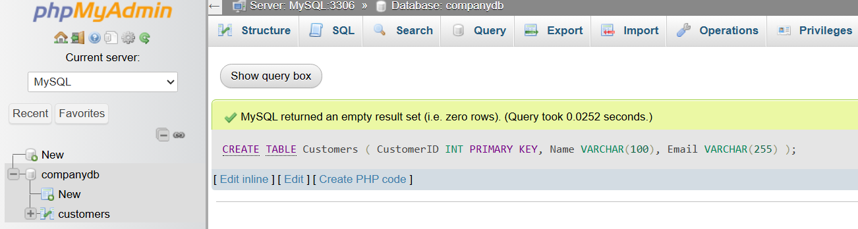

Example
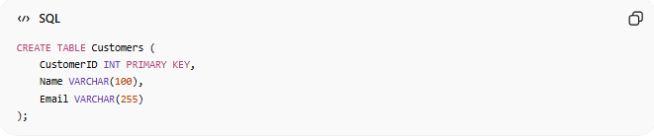
CREATE TABLE Customers (
CustomerID INT PRIMARY KEY,
Name VARCHAR(100),
Email VARCHAR(255)
);

Result
Creates:
CustomerID | Name | Email
An empty table.

2️⃣ ALTER TABLE
# Source: AI Source: Provided by: [Data Path: Persons Table -> ID Column: 1, Name_En Column: Motasem Essam] -> From: [ChatGPT] on [6/11/2026]
Purpose
Modifies an existing table.
Used to:
- Add columns
- Remove columns
- Rename columns
- Change data types

Add Column
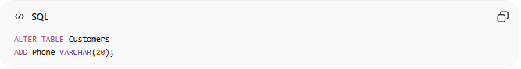
ALTER TABLE Customers
ADD Phone VARCHAR(20);

Before
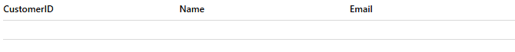
CustomerID | Name | Email

After
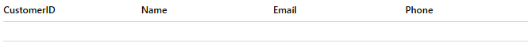
CustomerID | Name | Email | Phone

Drop Column
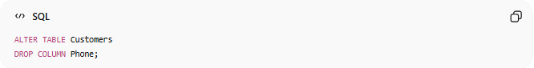
ALTER TABLE Customers
DROP COLUMN Phone;

Modify Column
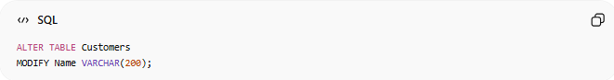
(MySQL)
ALTER TABLE Customers
MODIFY Name VARCHAR(200);

Real Example

prepared commands
# Source: ScreenShot Source: Provided by: [Persons Table -> ID Column: 1, Name_En Column: Motasem Essam] -> Tool: [Automation Table -> ID Column: 16, Name_En Column: Screen Capture] -> From [Operating System: Wampserver64 -> phpmyadmin] on [6/11/2026]

CREATE TABLE Customers (
CustomerID INT PRIMARY KEY,
Name VARCHAR(100),
Email VARCHAR(255)
);


basic command
# Source: ScreenShot Source: Provided by: [Persons Table -> ID Column: 1, Name_En Column: Motasem Essam] -> Tool: [Automation Table -> ID Column: 16, Name_En Column: Screen Capture] -> From [Operating System: Wampserver64 -> phpmyadmin] on [6/11/2026]
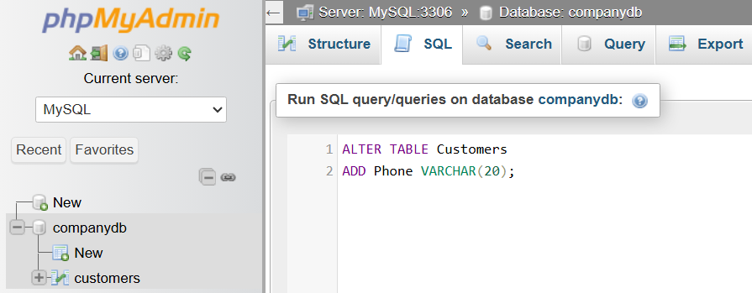
ALTER TABLE Customers
ADD Phone VARCHAR(20);
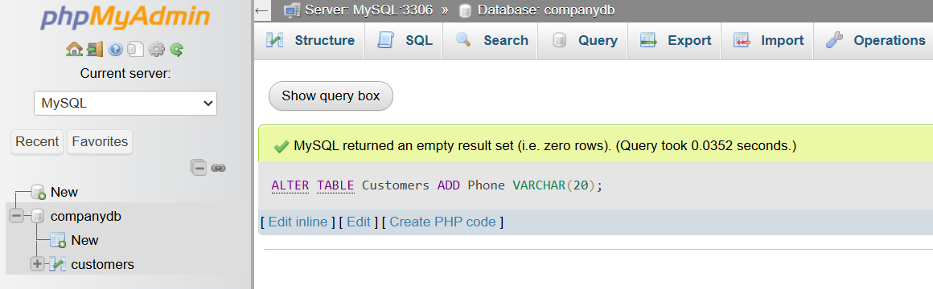

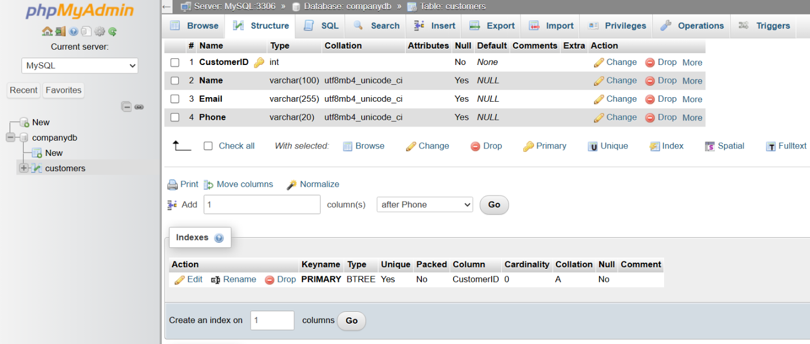

3️⃣ RENAME TABLE
# Source: AI Source: Provided by: [Data Path: Persons Table -> ID Column: 1, Name_En Column: Motasem Essam] -> From: [ChatGPT] on [6/11/2026]
Purpose
Changes the table name.
Syntax
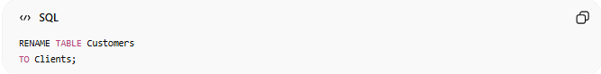
RENAME TABLE Customers
TO Clients;

Result
Before:
Customers
After:
Clients

Real Example

prepared commands
# Source: ScreenShot Source: Provided by: [Persons Table -> ID Column: 1, Name_En Column: Motasem Essam] -> Tool: [Automation Table -> ID Column: 16, Name_En Column: Screen Capture] -> From [Operating System: Wampserver64 -> phpmyadmin] on [6/11/2026]

CREATE TABLE Customers (
CustomerID INT PRIMARY KEY,
Name VARCHAR(100),
Email VARCHAR(255)
);


basic command
# Source: ScreenShot Source: Provided by: [Persons Table -> ID Column: 1, Name_En Column: Motasem Essam] -> Tool: [Automation Table -> ID Column: 16, Name_En Column: Screen Capture] -> From [Operating System: Wampserver64 -> phpmyadmin] on [6/11/2026]
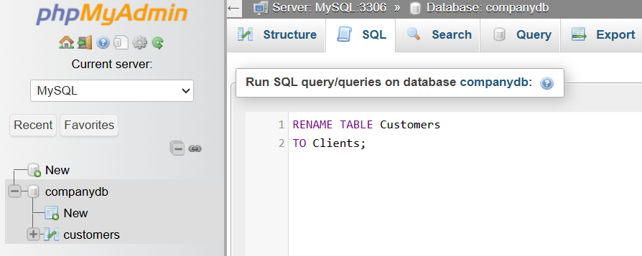
RENAME TABLE Customers
TO Clients;
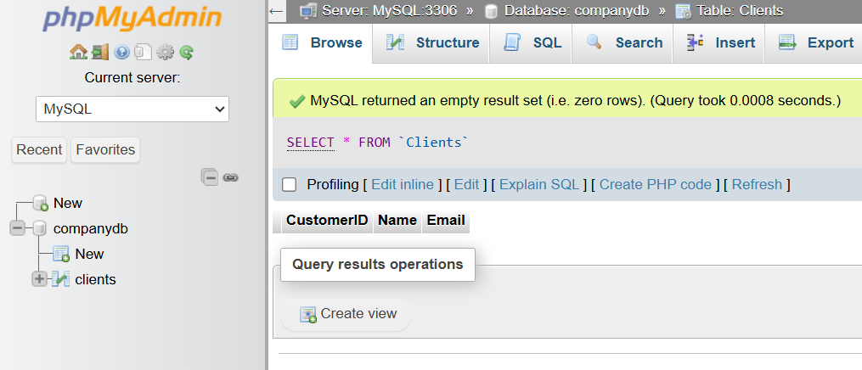

4️⃣ TRUNCATE TABLE
# Source: AI Source: Provided by: [Data Path: Persons Table -> ID Column: 1, Name_En Column: Motasem Essam] -> From: [ChatGPT] on [6/11/2026]
Purpose
Removes all rows from a table.
Syntax
TRUNCATE TABLE Customers;

Before
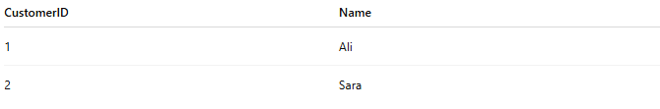
CustomerID | Name
1 | Ali
2 | Sara

After
CustomerID | Name
Table remains, data is removed.

Difference from DELETE
DELETE
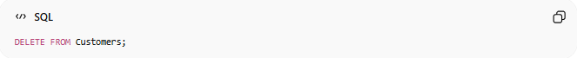
DELETE FROM Customers;
Removes rows one by one.

TRUNCATE
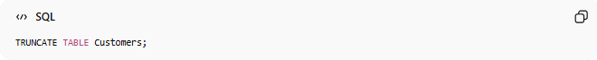
TRUNCATE TABLE Customers;
Much faster for clearing all data.

Real Example

prepared commands
# Source: ScreenShot Source: Provided by: [Persons Table -> ID Column: 1, Name_En Column: Motasem Essam] -> Tool: [Automation Table -> ID Column: 16, Name_En Column: Screen Capture] -> From [Operating System: Wampserver64 -> phpmyadmin] on [6/11/2026]

CREATE TABLE Customers (
CustomerID INT PRIMARY KEY,
Name VARCHAR(100),
Email VARCHAR(255)
);

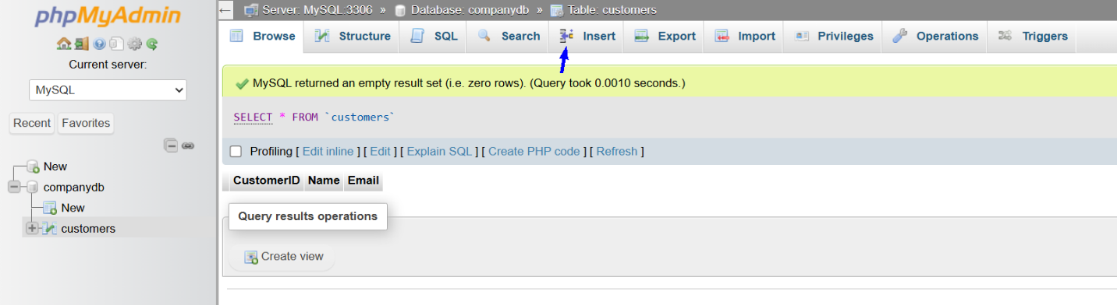
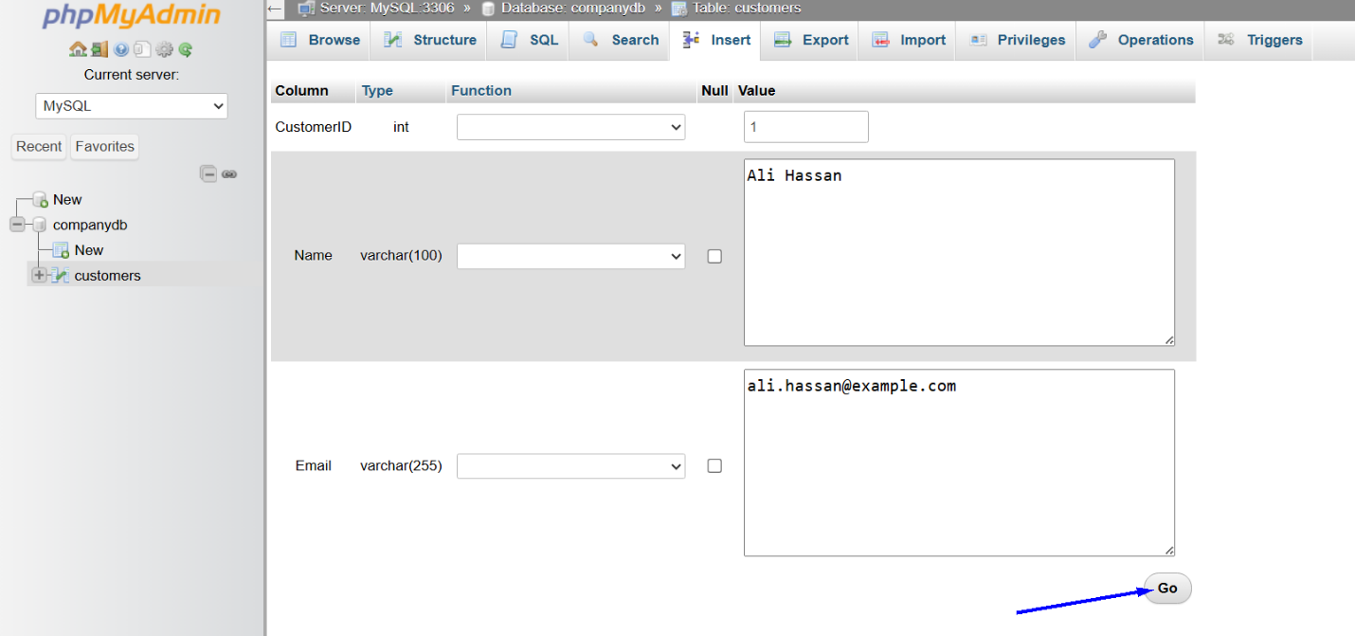
1
Ali Hassan
ali.hassan@example.com
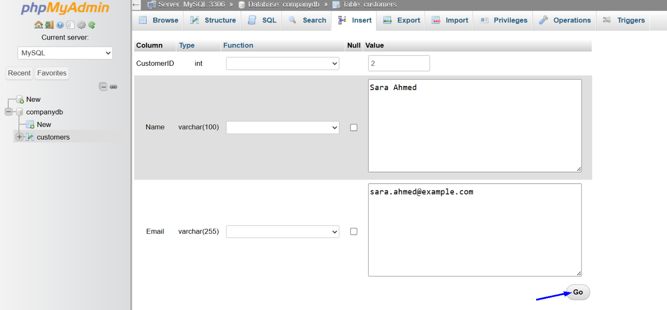
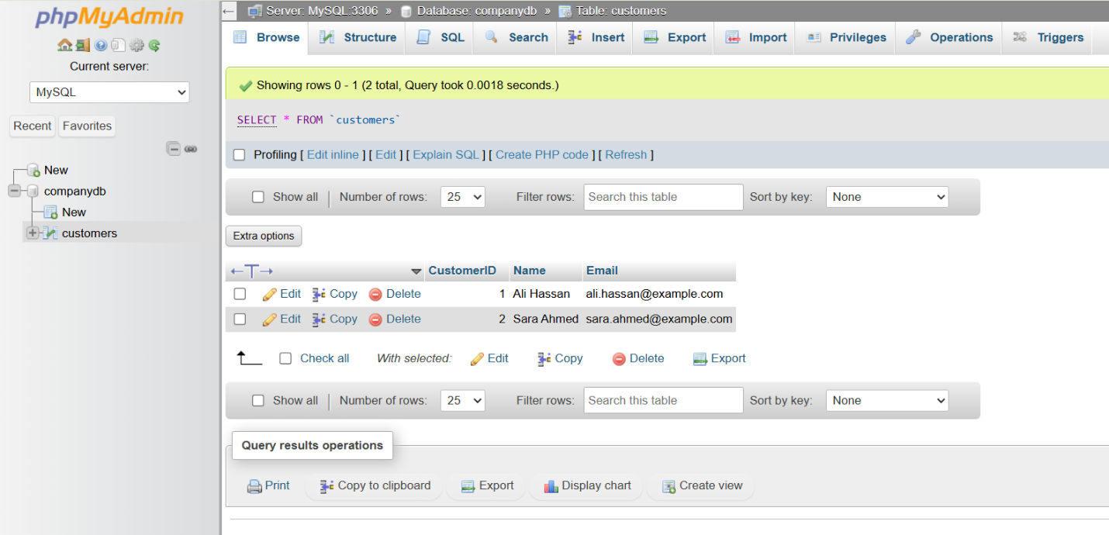

basic command
# Source: ScreenShot Source: Provided by: [Persons Table -> ID Column: 1, Name_En Column: Motasem Essam] -> Tool: [Automation Table -> ID Column: 16, Name_En Column: Screen Capture] -> From [Operating System: Wampserver64 -> phpmyadmin] on [6/11/2026]
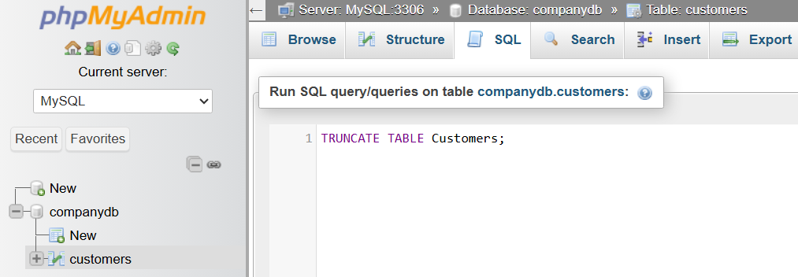
TRUNCATE TABLE Customers;
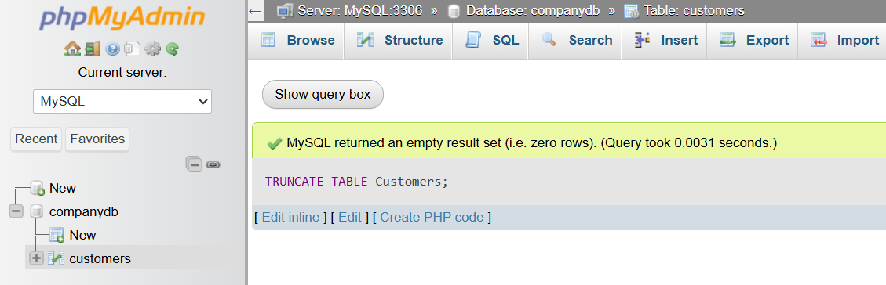
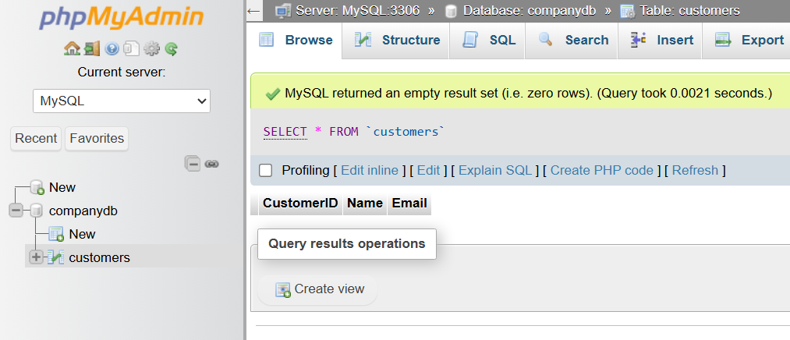

5️⃣ DROP TABLE
# Source: AI Source: Provided by: [Data Path: Persons Table -> ID Column: 1, Name_En Column: Motasem Essam] -> From: [ChatGPT] on [6/11/2026]
Purpose
Deletes an entire table.
Syntax
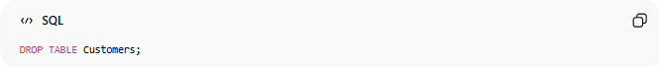
DROP TABLE Customers;

Before
Customers
exists.

After
Customers
no longer exists.

⚠️ Both structure and data are permanently removed.

Real Example

prepared commands
# Source: ScreenShot Source: Provided by: [Persons Table -> ID Column: 1, Name_En Column: Motasem Essam] -> Tool: [Automation Table -> ID Column: 16, Name_En Column: Screen Capture] -> From [Operating System: Wampserver64 -> phpmyadmin] on [6/11/2026]

CREATE TABLE Customers (
CustomerID INT PRIMARY KEY,
Name VARCHAR(100),
Email VARCHAR(255)
);


basic command
# Source: ScreenShot Source: Provided by: [Persons Table -> ID Column: 1, Name_En Column: Motasem Essam] -> Tool: [Automation Table -> ID Column: 16, Name_En Column: Screen Capture] -> From [Operating System: Wampserver64 -> phpmyadmin] on [6/11/2026]
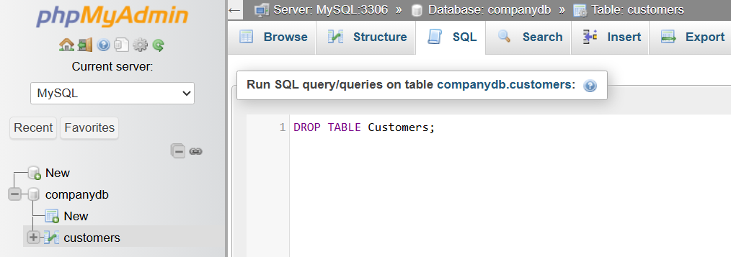
DROP TABLE Customers;


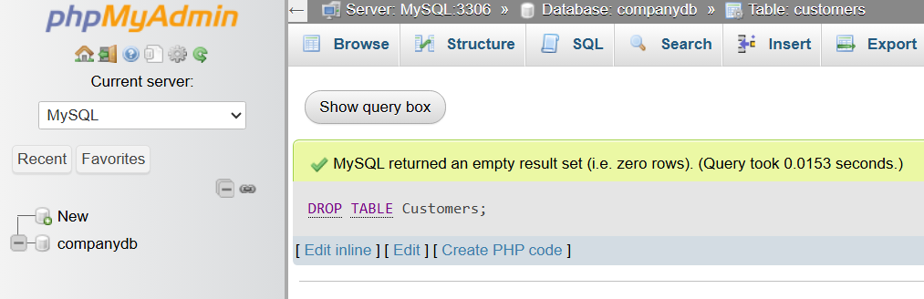

📊 Side-by-Side Comparison
# Source: AI Source: Provided by: [Data Path: Persons Table -> ID Column: 1, Name_En Column: Motasem Essam] -> From: [ChatGPT] on [6/11/2026]
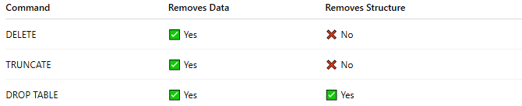
Command | Removes Data | Removes Structure
DELETE | ✅ Yes | ❌ No
TRUNCATE | ✅ Yes | ❌ No
DROP TABLE | ✅ Yes | ✅ Yes

🔢 Typical Workflow
# Source: AI Source: Provided by: [Data Path: Persons Table -> ID Column: 1, Name_En Column: Motasem Essam] -> From: [ChatGPT] on [6/11/2026]
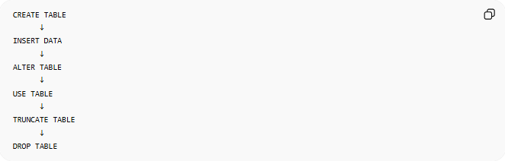
CREATE TABLE
↓
INSERT DATA
↓
ALTER TABLE
↓
USE TABLE
↓
TRUNCATE TABLE
↓
DROP TABLE

🧠 Simple Analogy
# Source: AI Source: Provided by: [Data Path: Persons Table -> ID Column: 1, Name_En Column: Motasem Essam] -> From: [ChatGPT] on [6/11/2026]
Think of a table as a spreadsheet.
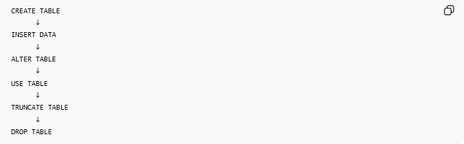
CREATE TABLE
Create a new spreadsheet
ALTER TABLE
Add a new column
TRUNCATE TABLE
Erase all rows
DROP TABLE
Delete the spreadsheet completely

🧭 Summary
# Source: AI Source: Provided by: [Data Path: Persons Table -> ID Column: 1, Name_En Column: Motasem Essam] -> From: [ChatGPT] on [6/11/2026]
SQL Table Commands are used to manage database tables. The most important commands are:
- CREATE TABLE → Create a table
- SHOW TABLES → List tables
- DESCRIBE → View table structure
- ALTER TABLE → Modify a table
- RENAME TABLE → Change table name
- TRUNCATE TABLE → Remove all rows
- DROP TABLE → Delete the table completely
These commands are part of DDL (Data Definition Language) and form the foundation of database structure management.

